Final 11.4.26

Goals:
Design traffic light pattern for an intersection.
While light A cycles through green and yellow, for 3 seconds each, light B remains red. When light A switches to red, light B begins the same cycle.
If a pedestrian needs to cross the street, there will be 2 buttons where if either are pressed will turns both lights red for 10 seconds, after the next yellow ends.

First I made a copy of my lab 7 because it used many similar parts. I needed the design for the traffic lights. As well as the down counter from 3.

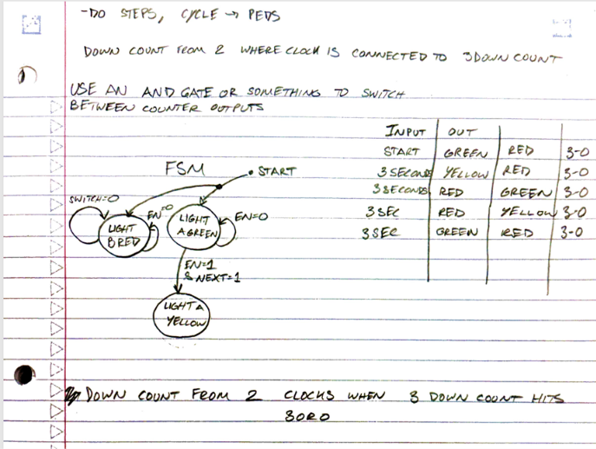
First brainstorm

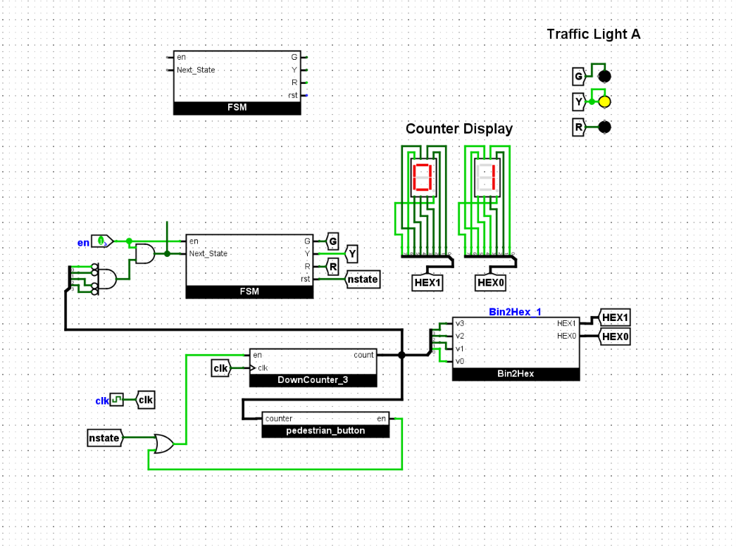
I noticed the enable pin was very simple and thought I could add on the logic needed for the third input, holding the status while the other light ran.

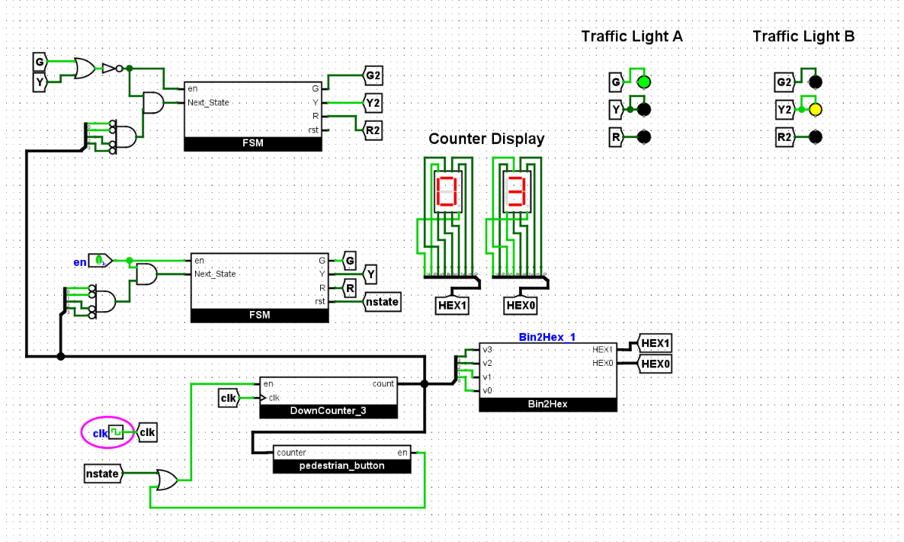
This was my first attempt using that logic. I knew it wasn’t going to work yet, because traffic light A was still always enabled.

I wasn’t sure how to make this work so decided to try my idea with the 2 bit counter.

2 Bit counter Idea
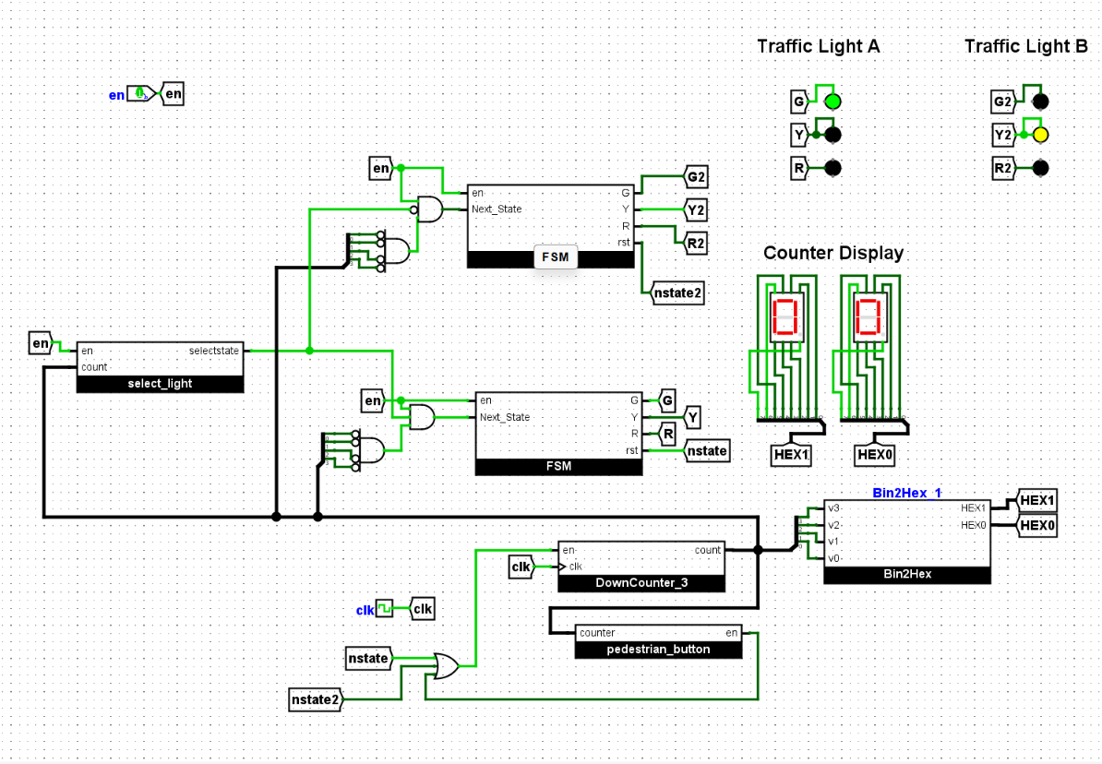
The thought process was to use a counter that was edge controlled by the same inputs controlling nstate.
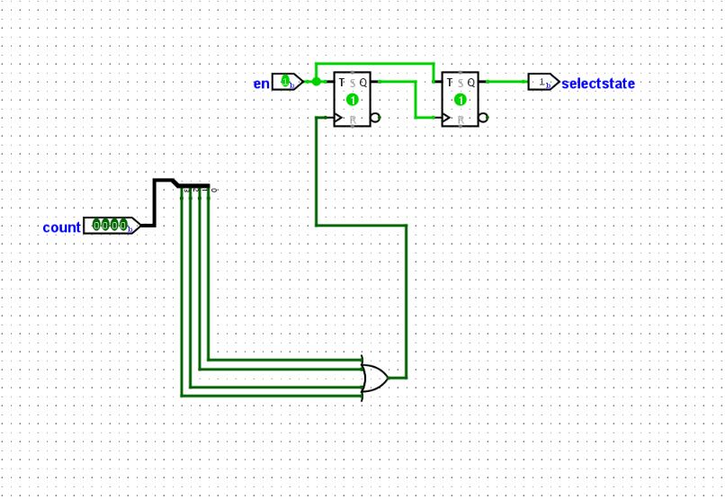

Other Attempts
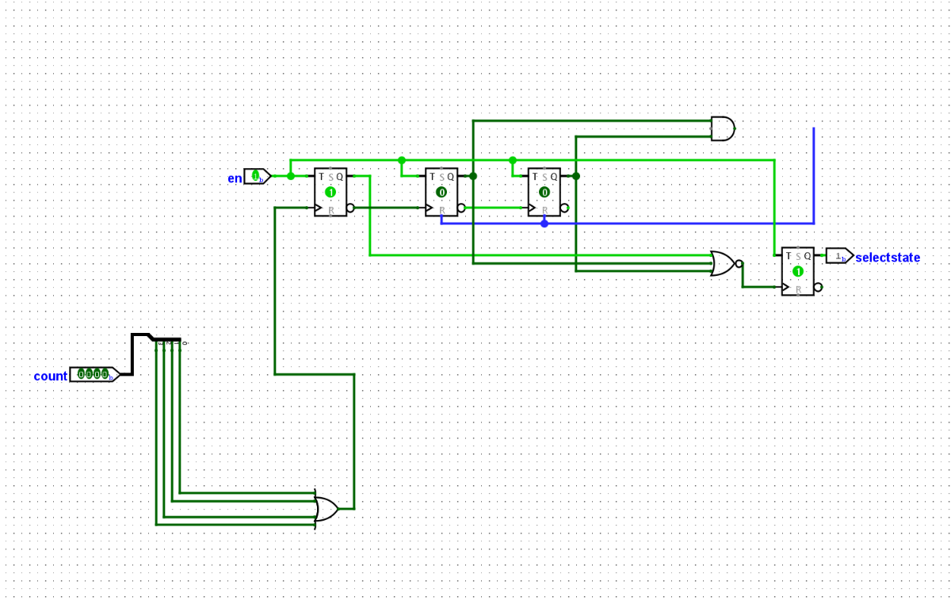
I kept trying different things. 3 bit counters, 4 bit counters. Different variations of and gates. But kept getting the same results.

It would cycle through which color to wait on. For one rotation of light A light B would stay red the whole time. But then the next rounds light b would rotate through all the colors while A was yellow.

This almost worked. But the current light wouldn’t switch to red before the next one started. I wasn’t sure what to do at this point, because if I made the counter wait for 3 state changes, they would both be red at the same time, which isn’t what was wanted.

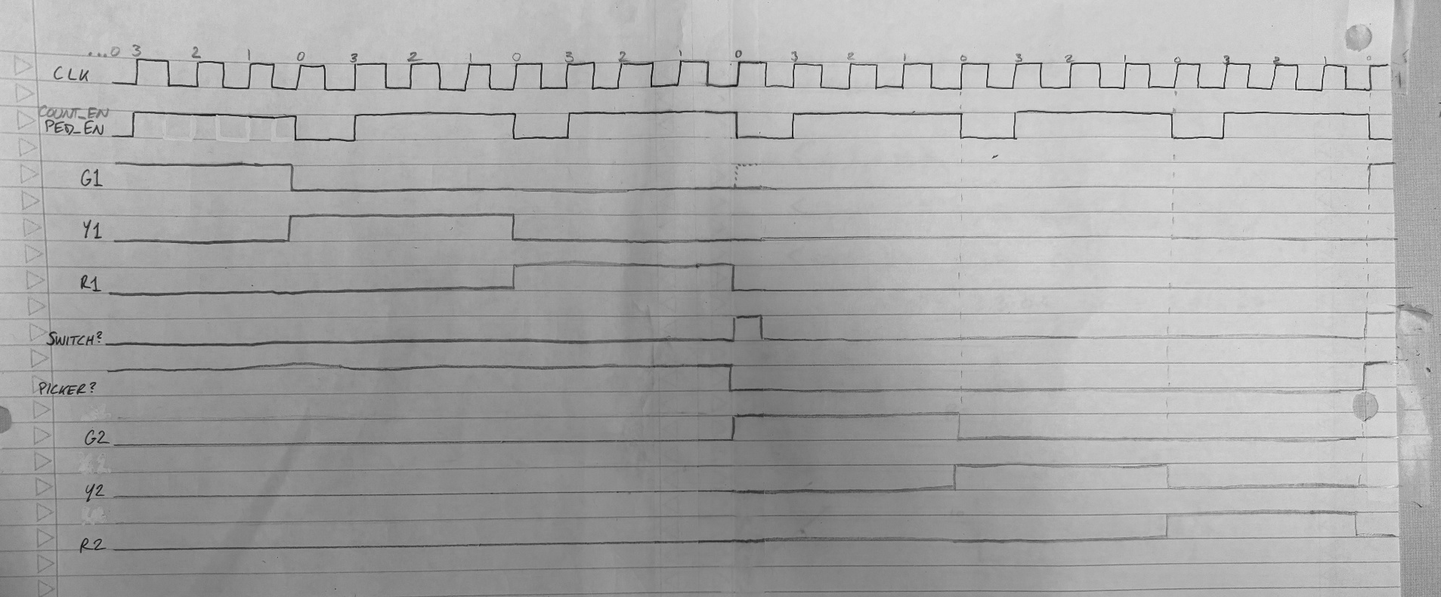
Clock Diagram

I drew this to help me figure out how things are shifting in line with each other. I had been keeping track previously in my head so this was way better.
I knew how the lights cycled independent of other light. [Represented by first cycle of G/Y/R(1)] and dependent on the clock and en pin
G/Y/R(2) could run using the same logic as G/Y/B(1) (the FSM Module) Which I was doing before, pulling in two of them to the main circuit.
I just needed a way to switch between the two lights. Two possibilities are labeled as switch and picker above. I just have to decide which is more efficient. The “switch” input which would toggle lights when high. This could be done with a t flip flop maybe? Q=Q’ when T=1 ? The “picker” input would enable light A when high and light B when low.
I think my issues previously had to do with me using a rising edge to dictate toggling between lights. Because when I used a rising edge to set, say switch=high, I would be using the same positive edge that was simultaneously toggling G1=high.
And this issue wouldn’t be eliminated by using a negative edge either because that’s the same as just using an earlier positive edge really. And the issue with that is it works for one rotation but then the cycle is off.
Maybe if there is a way to use an earlier positive edge to trigger an output, but then reset the memory element to 0? I feel like I may have tried that already but I forgot to document so I will try again.

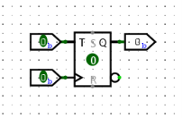
T Flip-Flop: On rising edge will inverse T input [Q=T’]
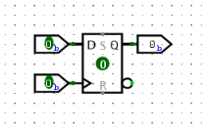
D Flip-Flop: On rising edge will set Q=D

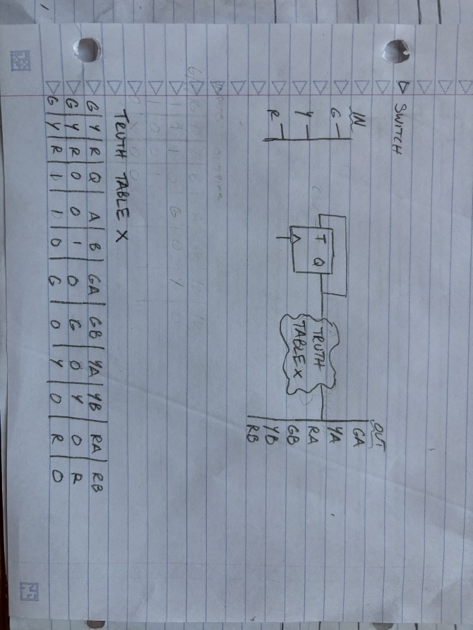
Another idea I had is to only use one FSM to cycle through G/Y/R and then feed that output through a light selector module?

I drew up this diagram, I would just need to figure out what to make the clock. Maybe since it is inside a module/ lightinputs need to pass through this logic first it will work now?
Ok now that Im looking at things my mistake might have just been using a positive edge switch with count_en as my edge?

I want the clock within this module to move at a 9th of the speed of the control clock. If I use count_en that is already about a 3rd as slow, and then I can build on that with a register? Something negative edge triggered
I guess I could use a 9 bit shift register. But I don’t really know how to use the prebuilt ones in Logisim and feel like I will mess it up if I do it myself.

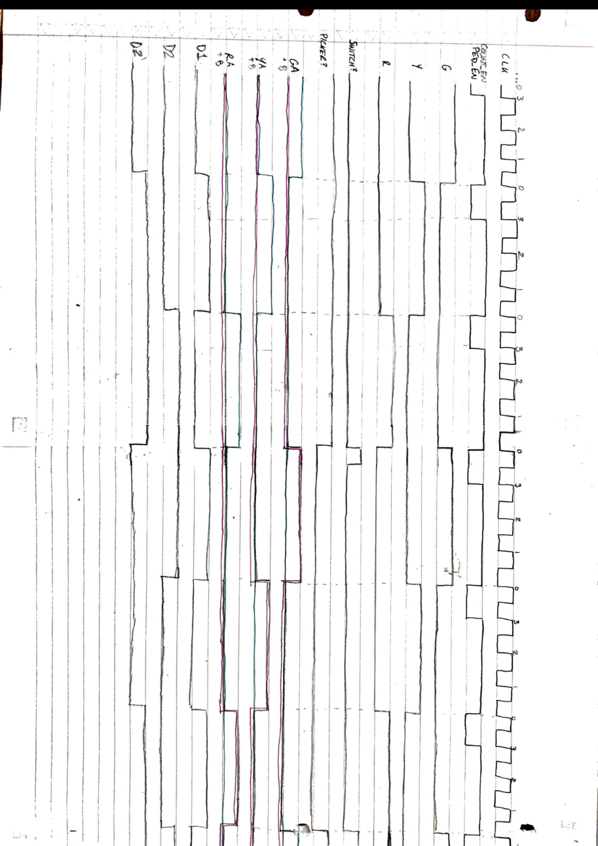
I added rows D1, D2, & D2’ playing around with some time waves that could be used for switch. They never matched up quite right though. It would be an edge sometimes but not all the time. I also made G/Y/R their own lines and combined the A/B Lights into one line, its color coded but doesn’t show up super strong in the photos.
I noticed, in doing this, that R has a negative edge when we want to switch. I don’t know if I could use that negative edge. But I could use R=1 in a shift register. Or no I should use G positive edge.

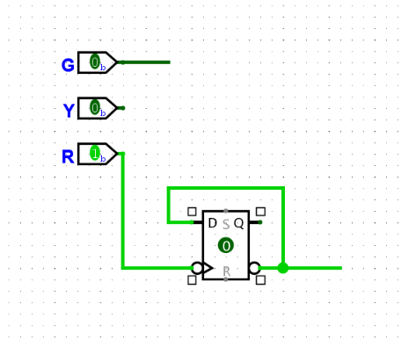
I think this will work for my truth table.

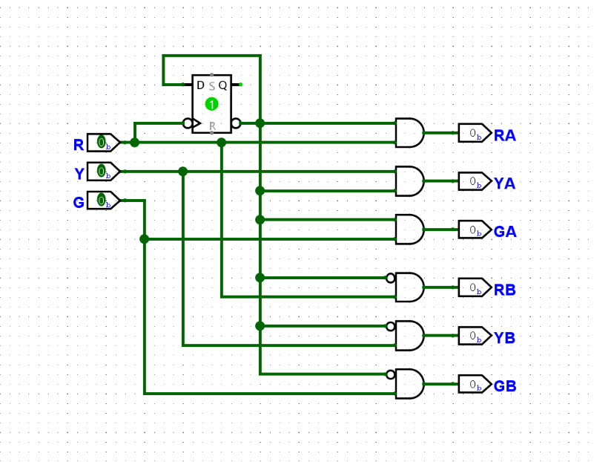
This was my first attempt making the truth table. Im sure there is a better way to do this with mulitplexors but just wanted to see if this worked first.

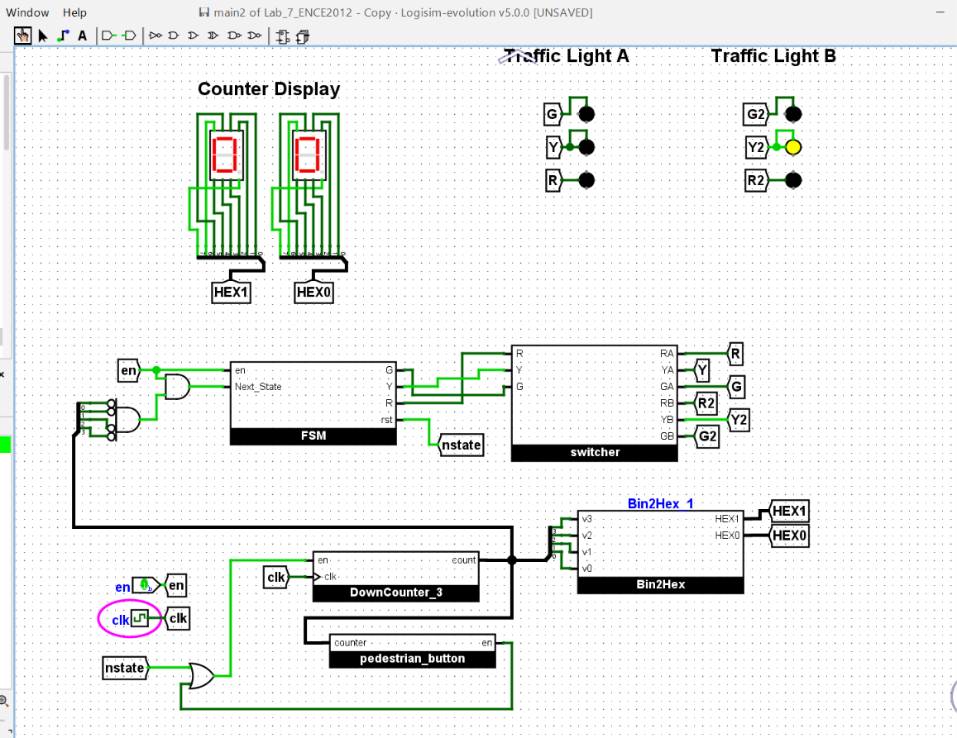
This almost worked. The lights were switching but the red light wasn’t staying on during the others cycle.
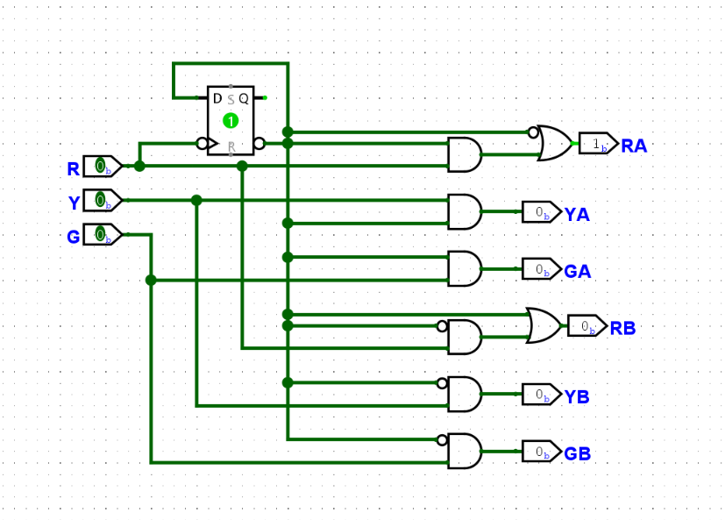
I just had to add in these or gates.

Pedestrian Button
I think the pedestrian button is best to add in to the switcher module
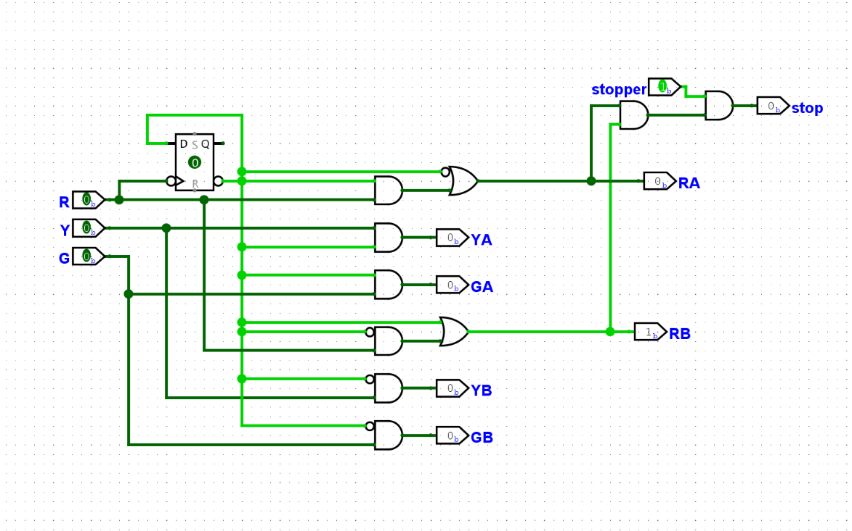
It would read a 0 most of the time and error when reds were high. And 1 when reds=high & stopper=high. I needed to figure out how to pause the system when the conditions were correct.
I might remove this from the switcher module. Because the whole timing system needs to stop not just the colors.

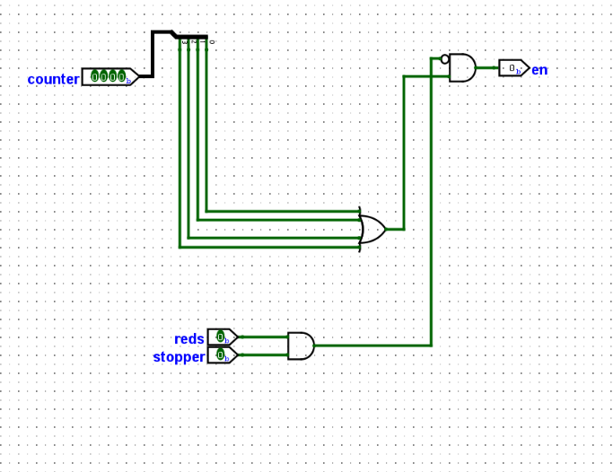
I added this to the pedestrian_button module. This worked at stopping both lights when the button was pushed and after the active rotation finished

The last thing I need to fix is the countdown. It needs to be from 10 and then also reset the pedestrian button

